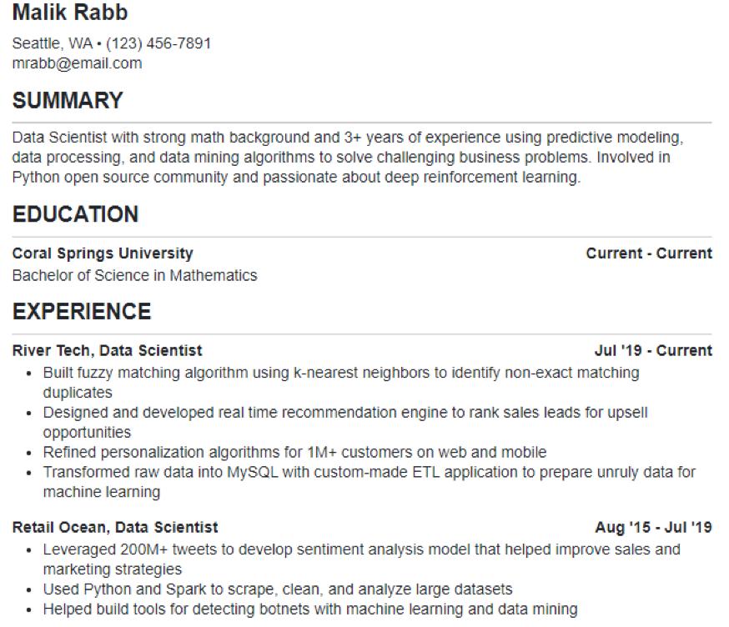
Malik Rabb
Seattle, WA. (123) 456-7891 mrabb@email.com
SUMMARY
Data Scientist with strong math background and 3+ years of experience using predictive modeling, data processing, and data mining algorithms to solve challenging business problems. Involved in Python open source community and passionate about deep reinforcement learning.
EDUCATION
Coral Springs University
Bachelor of Science in Mathematics
EXPERIENCE
River Tech, Data Scientist
Current - Current
Jul '19 - Current
• Built fuzzy matching algorithm using k-nearest neighbors to identify non-exact matching duplicates
• Designed and developed real time recommendation engine to rank sales leads for upsell opportunities
• Refined personalization algorithms for 1M+ customers on web and mobile
• Transformed raw data into MySQL with custom-made ETL application to prepare unruly data for machine learning
Retail Ocean, Data Scientist
Aug '15 - Jul '19
• Leveraged 200M+ tweets to develop sentiment analysis model that helped improve sales and marketing strategies
• Used Python and Spark to scrape, clean, and analyze large datasets
• Helped build tools for detecting botnets with machine learning and data mining

